


Chitkara University Institute of Engineering and Technology
BE (Software Engineering)
Data Capture Technologies (SIT123)
ECOTECH

Name – Moulik Mahajan
Rollno- 2210994815
Semester- 2 ^{nd} , Batch 2022

Student Declaration
• I declare that this assessment is my work and demonstrates my abilities and
knowledge and does not involve plagiarism.
• I have taken serious precautions to make sure other students do not copy my work.
• I declare that I have properly provided all the citations and references to the sources
when I had to present ideas that are not my own.
• I understand very clearly that plagiarism can result in a penalty of zero marks for the assessment.
• I understand that serious offenses of plagiarism (e.g. submitting work of students from a previous
semester, or hired services work) will be forwarded to the faculty for further action.

Student name: Moulik Mahajan
Signature:
Date:29/05/23

Table of Contents
1. Introduction
1.1 Problem Statement
1.2 Need for Proposed Solution
1.3 Hypothesis/ Research Questions
2. Literature Review/ Background
3. Detailed Description of Approach
3.1 Architecture of System Components (as per sense-think-act paradigm)
3.2 Major Components
3.3 Circuit Diagram and Working
3.4 Photos/ Video of Actual Hardware
4. Data Collection Process
5. Ethical Concerns
6. Results and Discussion
6.1 Testing of Hypothesis
6.2 Data Visualisation
7. Challenges and Lessons Learnt
8. Future Work (proposal for future extension of the project)
9. References

INTRODUCTION
Plant preservation and care are crucial for keeping greenhouses healthy and productive. Due to a lack of funding and technical assistance, local greenhouse owners frequently encounter substantial obstacles when efficiently monitoring and preserving their plants. In this project, we suggest an Arduino-based plant monitoring system to solve these issues and offer a productive remedy for neighborhood greenhouse management.
1.1 Problem Statement

Local greenhouses have multiple varieties of plants that are supposed to preserve but they go through a lot of challenges and sometimes this leads them to a heavy loss. As there are some of the major challenges they faced are –
1)No real-time monitoring of the plant- Traditional monitoring methods are very lazy and are done by human observation this can lead to human error which is a major concern. Without continuous data monitoring, they can only rely on weekly and monthly observation which can ultimately lead to damage to the plant.
2)Ineffective use of resources – Without the automated plant real-time monitoring can lead to inefficient use of the resources. The Greenhouse worker may provide excess or less water, may damage the plant by providing excess pesticides, and excess exposure to sunlight may hinder the plant’s growth and yield.
3)Inaccurate Data collection -Incomplete or erroneous data can be produced by traditional data-gathering techniques, such as manual record-keeping, used in greenhouses. Due to this, it is difficult for operators to analyze trends, spot patterns, and come to data-driven choices for the management and maintenance of plants.
4) Limited scalability and adaptability: Many neighborhood greenhouses lack the technological resources and infrastructure required to set up sophisticated monitoring systems. Their capacity to grow their activities efficiently and adjust to shifting environmental conditions is constrained by this restriction.
1.2 Need for Proposed Solution
The need for the recommended plant monitoring system using Arduino was driven by the unique challenges that nearby greenhouses face while trying to manage their plants. These issues highlight the necessity for establishing an automated and integrated solution and highlight the limitations of traditional monitoring systems. The following details further clarify the necessity of the recommended remedy:
- Local greenhouse enterprises usually suffer from a lack of finance as well as specific plant care and monitoring skills. Limited resources and experience. A sophisticated monitoring system may compensate for these shortfalls by providing real-time data and insights that aid in making decisions on plant preservation.
- Inefficient resource usage may result from using traditional monitoring strategies, including manual observation. Inadequate watering or bad illumination may have a substantial influence on plant health and yield. By including sensors that gauge soil moisture, light intensity, and other factors, the proposed system offers precise resource management, ensuring that plants are given the ideal conditions for growth.
- Real-time monitoring for timely response: The capacity to react swiftly to changes in plant health indices is essential for effective preservation. Traditional approaches can rely on erratic observations, which makes it challenging to identify and address problems as soon as they arise. The suggested method provides ongoing real-time monitoring, enabling greenhouse managers to see abnormalities and take prompt action to stop plant loss or damage.
- Th decision-making is done on the data that is collected in real-time monitoring. The given solution is proposed by analyzing the data in the patterns and the trends of the graph that appear in real-time.
- It is the best and the cheap way as it is done using the microcontroller that is Arduino it is easily expandible and can be accommodated according to the specific needs of the user.
1.3 Hypothesis / Research Questions
- Does utilizing an Arduino-based plant monitoring system increase the effectiveness of resource usage in nearby greenhouses?
- How much is the preservation and general health of plants in greenhouses influenced by real-time monitoring of soil moisture, light intensity, pH levels, CO2 concentration, and temperature?
- How do the management techniques and results of greenhouse operators change as a result of data-driven decision-making made possible by the plant monitoring system?
- What are the advantages and drawbacks of constructing the plant monitoring system utilizing Arduino microcontrollers in terms of cost-effectiveness, scalability, and adaptability?
- What effects does the plant monitoring system have on plant health, production, and the sustainability of the greenhouse as a whole?
2. Literature Review/ Background
- Greenhouse Monitoring Systems: These systems have received a lot of attention recently as a result of their success in optimizing plant growth and preservation. To monitor crucial greenhouse environmental parameters including temperature, humidity, light intensity, and air quality, these systems employ a range of sensors. By acquiring real-time data, greenhouse managers may make informed decisions and take the required actions to maintain the ideal growing circumstances for plants. [1][2]
- MQ135 Gas Sensor: For detecting gases like carbon dioxide (CO2) and volatile organic compounds (VOCs), the MQ135 gas sensor is often used for air quality monitoring. By integrating the MQ135 sensor into the plant monitoring system, greenhouse operators may monitor the CO2 levels within the greenhouse. This information aids in managing the composition of the surrounding air and maximizing ventilation to support maximum plant growth and productivity.[3]
- Soil Moisture Sensors: By accurately measuring the amount of soil moisture, soil moisture sensors are essential components of plant monitoring systems. With the help of these sensors, irrigation can be timed precisely, protecting plants from both over- and underwatering. For measuring soil moisture, sensors based on capacitance, resistance, and frequency domain reflectometry (FDR) are frequently utilized.[4]
- Light-dependent resistor, or LDR Photoresistor, and light-dependent resistor (LDR) sensors are used to measure light intensity. They are often used in plant monitoring systems to assess the lighting conditions in the greenhouse. Monitoring light levels improves the efficiency of lighting schedules and ensures that plants get enough light to sustain photosynthesis and growth. [5]
- The temperature of an object may be measured without making direct touch using infrared temperature sensors. These sensors may be included in systems for monitoring plants to determine the temperature of the surroundings, canopy, or leaves. The enhancement of greenhouse temperature management and the diagnosis of diseases are all made possible with the help of temperature monitoring.[6]
- The DHT22 sensor, sometimes called the AM2302 or DHT22, combines a humidity and temperature sensor. It offers precise measurements of the ambient temperature and relative humidity. Operators of the greenhouse can produce the optimum growth conditions for a variety of plant species by keeping an eye on the humidity levels. Plant transpiration and general plant health are greatly influenced by humidity.[7][8]
3. Detailed Description of Approach
3.1 Architecture of System Components (as per sense-think-act paradigm)
Sense: At this point, the system makes use of sensors to collect data or information about its surroundings. The sensors locate and measure particular characteristics that are crucial to the system's objective. A plant monitoring system makes use of sensors to assess variables including soil moisture, temperature, humidity, light intensity, and gas concentrations. These sensors capture data differently.
Think: After data is acquired, the system processes and analyses it to deliver meaningful information or serve as a decision-making tool. This stage requires the use of algorithms, rules, or logical processes to evaluate the sensor data and extract essential information. A microcontroller such as Arduino is used to process the data.
Act: Following data analysis, the system takes the appropriate steps in line with any conclusions or decisions made. These include actions like setting off a buzzer to signify low soil moisture are some examples of activities that might be taken in the context of a plant monitoring system. In our system, we have added the message analyzer which prints the message after analyzing all the data and tells the user to act accordingly.
The sense-think-act paradigm ensures that the system actively perceives and observes its environment, processes the data gathered and responds with the required actions. The plant monitoring system can effectively monitor and manage the growth conditions of the plant thanks to the autonomous operation and decision-making capabilities of this framework.
3.2 Major Components
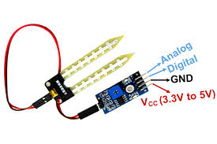
- SOIL MOISTURE – This Sensor is used to measure the amount of soil moisture present in the soil and act accordingly if the amount of moisture is less in the soil than a certain value then it will send a signal to Arduino and then the buzzer starts buzzing.
- Infrared temperature sensor – This sensor is used to provide the live ambient temperature of the greenhouse which generated the message that whether the plant is suitable for the environment or not
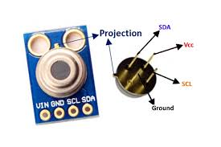
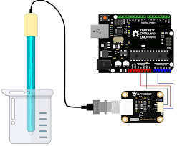
- PH – This sensor is used to check the ph quality of the soil which acts as the major component in plant growth some soil solution is made and the sensor is dipped inside it automatically analyzes the ph value of the soil whether it is acidic, neutral or basic.

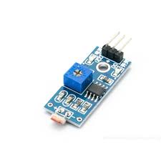
- Light intensity sensor – This sensor is used to measure the intensity of the light in the green and also tell about how much light is sufficient for plants or not.

- Dht22 sensor – This Sensor is used to measure the humidity and tell whether this humidity level is suitable for plants or not
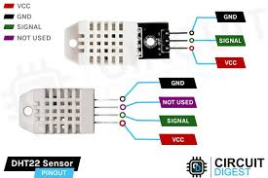

- Arduino uno – This is the main processor which is the brain of the plant monitoring system all the processing is done in it
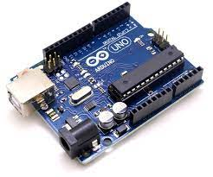

3.3 Circuit Diagram and Working

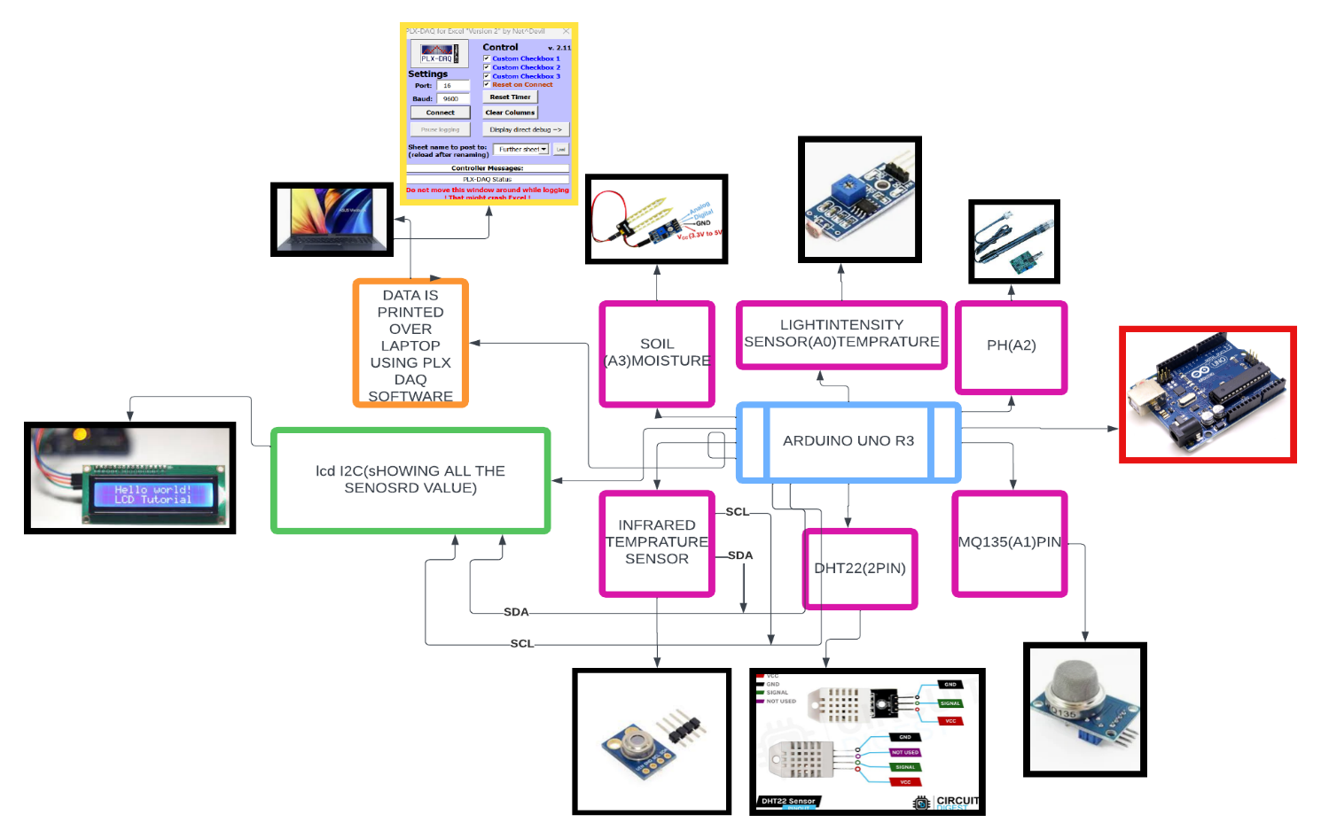
In this we have used various sensors all the data is sent to the Arduino which is the main component and acts as the brain of our eco-tech all the sensors data is captured live and the value of the sensor is set accordingly when the moisture level decreased in the soil the message is sent that moisture is decreased and the buzzer start buzzing also the data is displayed on the LCD during the data saving the chart is also made life which user can analyze.
3.4 Photos/ Video of Actual Hardware
VIDEO LINK- https://youtu.be/Qd3IMkTKD7A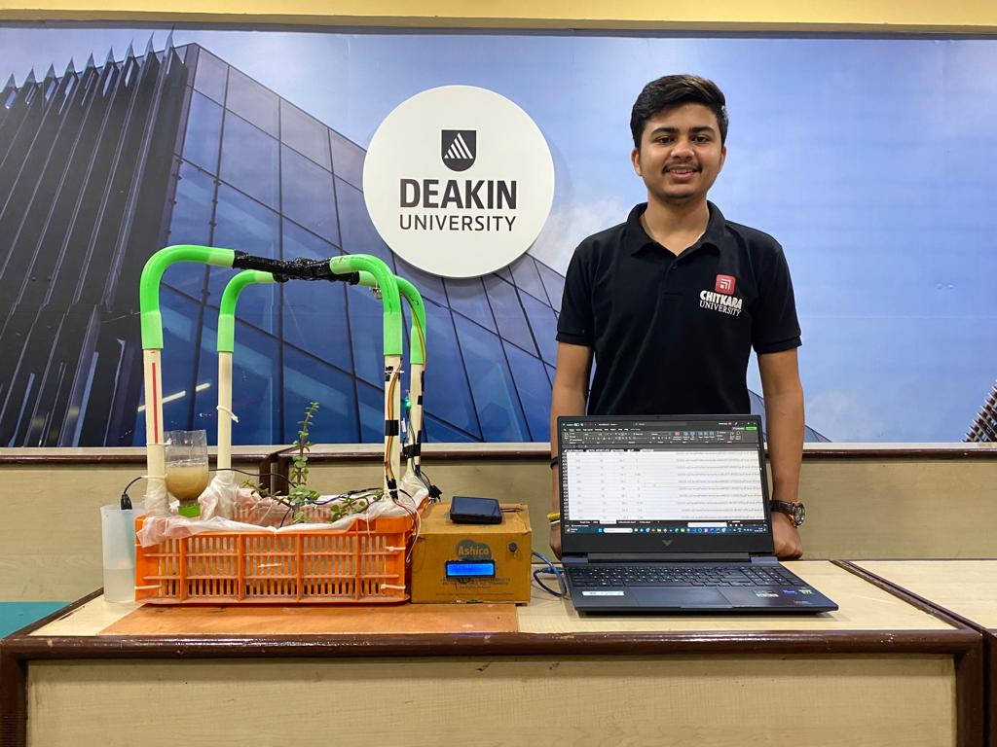
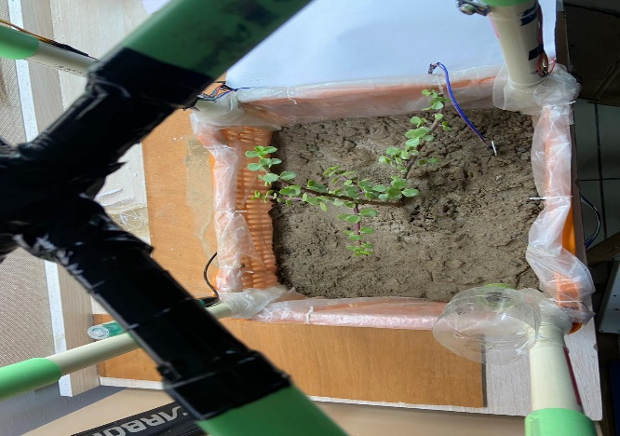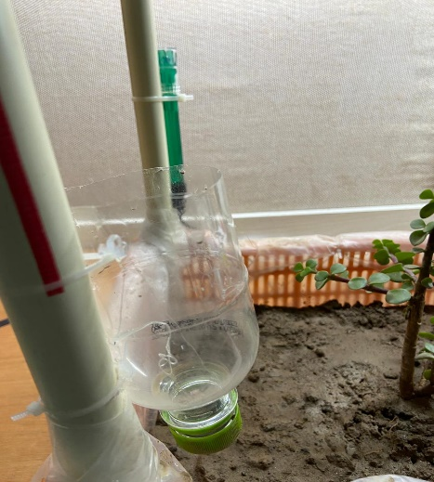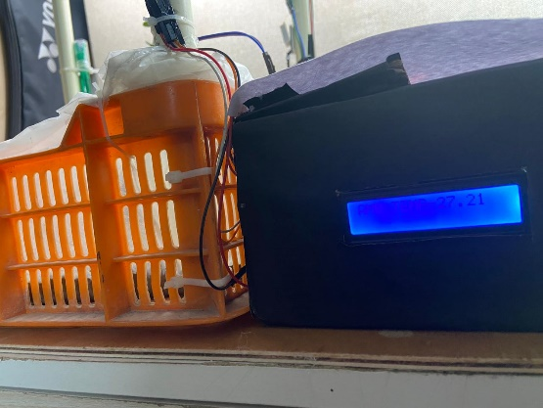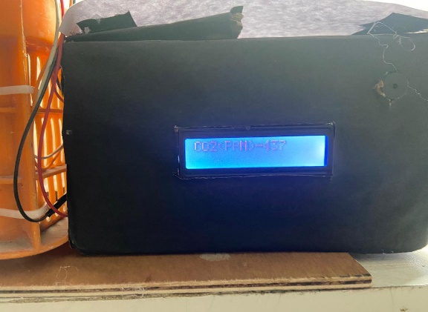

4. Data Collection Process
The plant monitoring system's data-collecting procedure entails compiling data from the many sensors placed throughout the greenhouse. Here is a description of the procedure for gathering data:

- Place the sensors in the correct places within the greenhouse to record the necessary environmental data. Place the light intensity sensor in a representative location, the CO2 sensor at an appropriate height, the soil moisture sensor in the root zone, and the temperature and humidity sensors in regions that reflect the general environment.
- Sensor Readings: On an ongoing basis, read the sensor data using the Arduino microcontroller. This can be done by developing communication protocols between the sensors and the microcontroller, such as transferring the data from Analog pins or digital pins.
- Data logging – We have done the data logging through the live software that is PLX DAQ this software directly captures the data from the Arduino and starts printing it on the Excel sheet we have also added the graph-making process which is one to be set then it automatically generates the live graph of the values as the values get added by the PLX DAQ software this help our user directly understanding the data live.

PLX DAQ COMMANDS – some commands there which are needed to be inserted in the Arduino ide to process the data according to and these commands are for the PLX DAQ which automatically divides the data into the sub-columns and the rows which will be avoiding the data merge and become a mess we to can set the rows. Our data rows. Our data logging also print the message based on certain observation of the sensor.
5. Ethical Concerns
- Sensor for Soil Moisture:
Check the accuracy and calibration of the soil moisture sensor to make sure it produces correct data. Inaccurate readings can result in poor watering techniques, which can have an impact on plant health and resource use.
Think about how the soil moisture sensor will affect the environment. Select a sensor that promotes sustainability by using less energy and leaving little of an environmental imprint.
- Sensor for Infrared Temperature:
Privacy: Think about how employing an infrared temperature sensor can affect your privacy. Ascertain that any private or delicate data gathered through temperature monitoring is handled safely and by privacy laws.
Verify the infrared temperature sensor's accuracy and dependability before using it to detect temperatures. Accuracy may be maintained and possible errors can be reduced with routine calibration and maintenance.
- MQ135 Sensor (Sensor of Air Quality):
Data Interpretation: Assure the proper interpretation of the data gathered from the MQ135 sensor. Recognize the sensor's limits and potential biases and consider them while analyzing air quality data.
Environmental Impact: Evaluate the MQ135 sensor's environmental impact. Take into account elements including energy usage, production techniques, and disposal strategies. Select sensors that put environmental responsibility and energy efficiency first.
- Sensor of light intensity:
Use energy responsibly by checking the energy efficiency of the lighting systems and the light intensity sensor. Using energy-saving bulbs or installing light automation depending on plant requirements, promote responsible energy use.
Light Pollution: Pay attention to light pollution that the lighting system's intensity may be causing. To have the least amount of an effect on adjacent populations and local animals, think about covering or directing light correctly.
- DHT22 Sensor (Temperature and Humidity Sensor):
Data Security: To safeguard the temperature and humidity data the DHT22 sensor collects, use strong data security techniques. Make sure the data is secured, that access is limited, and that privacy is upheld.
Precision and dependability: To guarantee accurate and dependable humidity and temperature readings, calibrate and maintain the DHT22 sensor regularly. Incorrect readings might result in poor plant maintenance and even harm.

6. Results and Discussion
6.1 Testing of Hypothesis
- Yes it increases the effectiveness of resource usage in the greenhouse because it decreases the excessive usage of the resources which saves the resources as this is only based on the conditions which are captured live and the analysis done live.
- There is a lot of increment in plant health as all the sensors such as soil moisture, light intensity sensor, infrared temperatures sensor, and carbon dioxide sensor data captured live, and on a certain value some data or message is sent to the user and the user will follow the process and act accordingly.
- All the management techniques data is provided by the system live in PLX DAQ and after analyzing the graph the user can make the decision accordingly.
- Compare the implementation costs of various monitoring systems with those of the Arduino-based plant monitoring system. Examine the system's capacity to manage to expand greenhouse sizes or integrate more sensors to determine its scalability and flexibility. Through interviews or surveys, elicit user input about their perceptions of the system's cost-effectiveness, scalability, and flexibility.
- Install the plant monitoring system in several greenhouses and gather information on metrics for measuring plant health, such as growth rates, disease incidence, and crop output. To evaluate the effect of the system on plant health, productivity, and overall greenhouse sustainability, compare the data from monitored greenhouses with historical data or control greenhouses. By gathering information, examining the findings, and formulating conclusions in light of the findings, these testing methodologies will assist you in evaluating the hypotheses and research questions. To achieve a thorough assessment, make carefully identify the precise measurements, data-gathering procedures, and analytic approaches that correspond with each hypothesis.

6.2 Data Visualisation
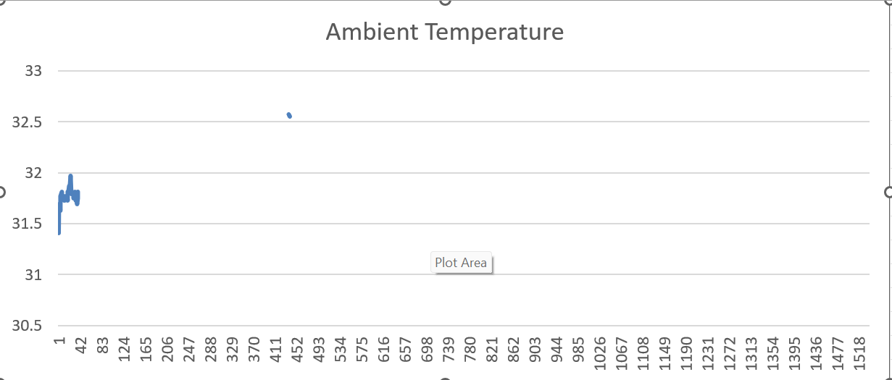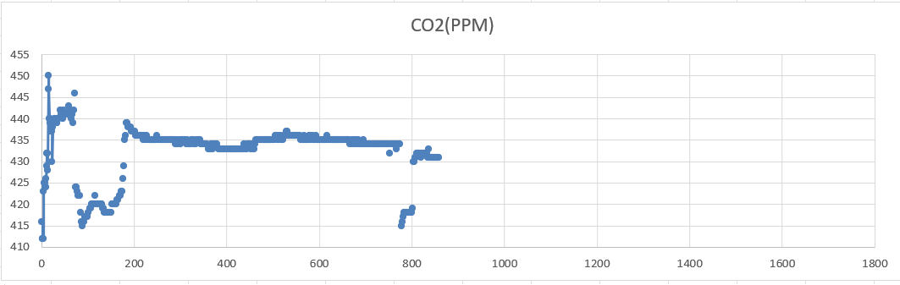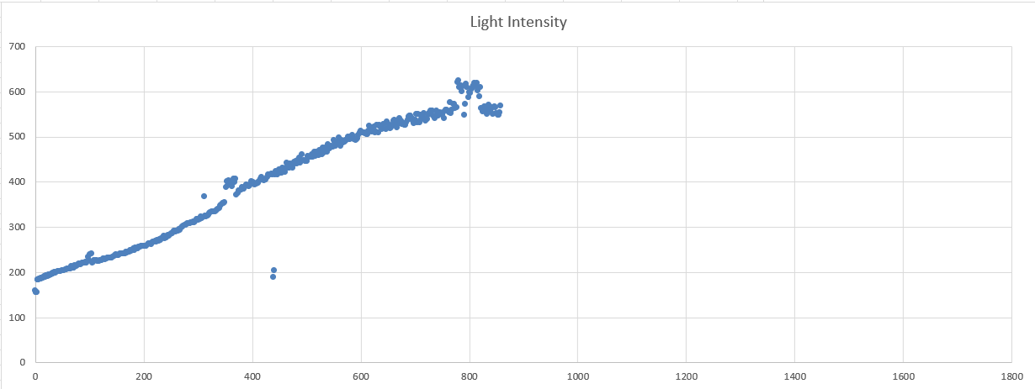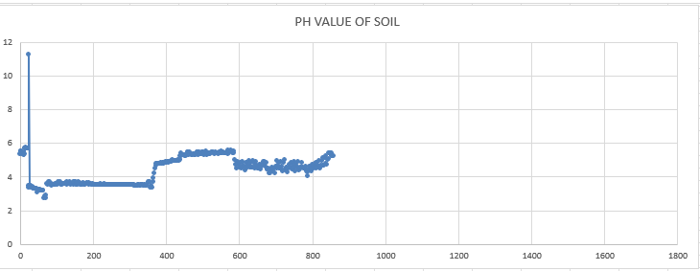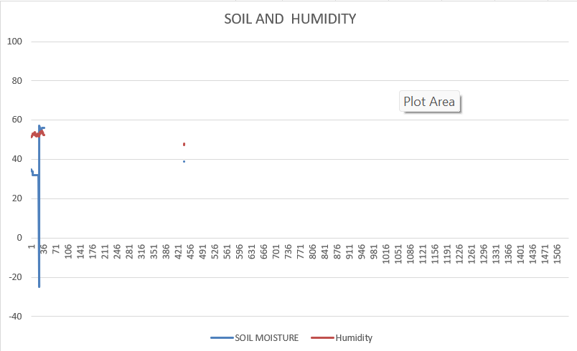

7. Challenges and Lessons Learnt
- I have faced a lot of challenges one of them is making the design of the greenhouse.
- Second challenge is how to contact the code to make the storage less.
- Another challenge is decreasing global variable declaration as it occupies a lot of space
8. Future Work (proposal for future extension of the project)
- In future scenarios this can be used to make the live data logging available on the phone which will help the user to check the status in real-time from anywhere in the world.
- More sensors can be added to make it more efficient
- More advanced systems can be made by adding AI, and ML to make them super smart.

9. References
- https://www.community.ruggedboard.com/post/iot-smart-agriculture [1]
- https://www.iotconnect.io/smart-greenhouse-solution.html [2]
- https://www.researchgate.net/publication/347167802_Design_Development_and_Validation_of_a_Portable_Gas_Sensor_Module_A_Facile_Approach_for_Monitoring_Greenhouse_Gases[3]
- https://www.sciencedirect.com/science/article/pii/S2772375521000320[4]
- https://greenhousemag.com/article/importance-of-measuring-light/[5]
- https://www.greenhousegrower.com/technology/infrared-thermometers-for-monitoring-plant-and-substrate-temperatures/[6]
- https://www.google.com/url?sa=t&rct=j&q=&esrc=s&source=web&cd=&ved=2ahUKEwj-rKaEtZv_AhUB-TgGHfTTAEoQFnoECCcQAQ&url=https%3A%2F%2Fwww.jpier.org%2Fac_api%2Fdownload.php%3Fid%3D20112202&usg=AOvVaw1ZB9qFN5KS7rfSDPAym0-d[7]
- https://www.researchgate.net/publication/312403569_How_to_Use_the_DHT22_Sensor_for_Measuring_Temperature_and_Humidity_with_the_Arduino_Board[8]
IMAGES REFERENCES-
- https://www.google.com/imgres?imgurl=https%3A%2F%2Fcomponents101.com%2Fsites%2Fdefault%2Ffiles%2Fcomponent_pin%2FMoisture-Sensor-Module-Pinout.jpg&tbnid=WE52EKAb7IpjzM&vet=12ahUKEwi2o6bnhJv_AhVc8TgGHTkkAuUQMygjegUIARD7Ag..i&imgrefurl=https%3A%2F%2Fcomponents101.com%2Fmodules%2Fsoil-moisture-sensor-module&docid=bTHt9DUjXynrzM&w=750&h=500&q=soil%20moisture%20sensor&ved=2ahUKEwi2o6bnhJv_AhVc8TgGHTkkAuUQMygjegUIARD7Ag
- https://www.google.com/imgres?imgurl=https%3A%2F%2Fcomponents101.com%2Fsites%2Fdefault%2Ffiles%2Fcomponent_pin%2FMLX90614-Pinout_2_0.jpg&tbnid=ij4eEqvbLkYQsM&vet=12ahUKEwirvK-X_pr_AhUPk9gFHT2oBPoQMygkegUIARD9Aw..i&imgrefurl=https%3A%2F%2Fcomponents101.com%2Fsensors%2Fmelexis-mlx90614-contact-less-ir-temperature-sensor&docid=qpoBQ8D8b9gF_M&w=750&h=500&q=infrared%20temperature%20sensor&ved=2ahUKEwirvK-X_pr_AhUPk9gFHT2oBPoQMygkegUIARD9Aw
- https://www.hackster.io/infoelectorials/project-021-arduino-liquid-ph0-14-detection-sensor-project-a92093
- https://www.indiamart.com/proddetail/light-sensor-ldr-module-7159777962.html
- https://circuitdigest.com/microcontroller-projects/interface-dht22-sensor-module-with-arduino
- https://www.silicontechnolabs.in/arduino-uno-r3-microcontroller-development-board

